NAME

Use the words in the table below to fill in the gaps in the text below.

Very simply, __________ means telling a computer to do something. Computers are dumb machines. They don’t know how to do anything. You have to tell them everything, and you have to get the details right. But if you give them the right __________, they can do many wonderful and amazing things.

An instruction is a basic command you give to a computer, usually to do a single, very specific thing.
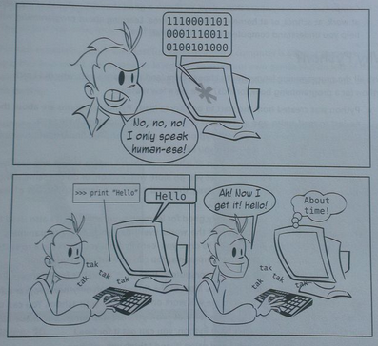
A computer program is made up of a number of instructions. Computers do all the great things they do today because a lot of smart programmers wrote programs or __________ to tell them how. Software just means a program or collection of programs that run on your computer, or sometimes on another yours is connected to, like a web server.

Computers __________ using lots and lots and lots of __________ circuits. At the most basic level, these circuits are switches that are either __________ or __________ . All these 1s and 0s are a kind of code called __________. This really just means two states.

What’s Going on in there?

All computers use binary, but most people don’t speak binary very well. We need an easier way to tell the computer what we want it to do. So people invented programming __________. A computer programming language lets us write things in a way that we can understand, and then __________ them into binary code for the computer to use.

Why Learn Programming?

Even if you don’t become a professional programmer (most people don’t), there are lots of reasons to learn programming.
- The most important is because you want to. Programming can be very interesting and rewarding, as a hobby or a profession.
- If you’re interested in computers and want to know more about how they work and how you can make them do what you want, that’s a good reason to learn about programming.
- Maybe you want to make your own games, or maybe you can’t find a program that does exactly what you want or need it to do, so you want to write your own.
- Computers are everywhere these days, so there’s a good chance you’ll use computers at work, school or at home - probably all three. Learning about programming will help you understand computers better in general.

On | Instructions | Binary | Electrical
Think | Translates | Programming | Languages
 | Off | Software

Think: Why do you want to learn programming? Write an answer below...

