Networks
Name: |  | Class:
Task 1: Name and describe the purpose of the following pieces of hardware needed in networks.
 | 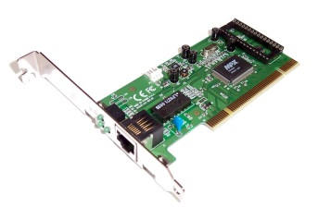 |  | 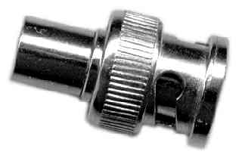
Name
What does it do?
Extension Activity: Describe 3 advantages and 2 disadvantages of a peer-to-peer network and a client-server network.
 | Peer-to-Peer Network | Client-Server Network
Advantage 1
Advantage 2
Advantage 3
Disadvantage 1
Disadvantage 2

