Small Basic
Task 1 – simple for loop
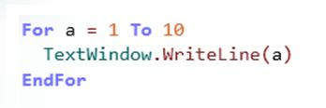

Task 2 – Multiplication tables
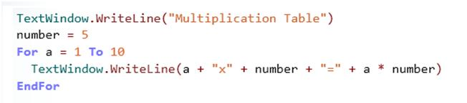

Extras - Can you write different tables? Try to make your program give the answers up to 12

Task 3 – count up in twos

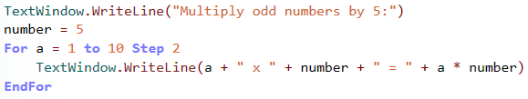

Extras – try to get your program to decrease each time a line is written
Task 4 – while loops

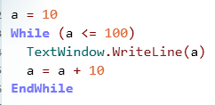
Independent task
