History of Computers
Name: |  | Class:

You are going to learn about the development of computers. Whilst you are listening, fill in this sheet with key facts.
Question. |  |  | Your answer
- Who was the first to use an abacus? |  | 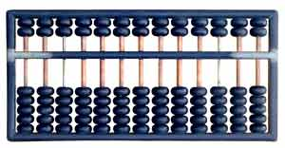
- Why did Pascal invent the first calculator in 1645?
- What does the “Stepped Reckoner” do that Pascal’s machine couldn’t?
- Who invented the “Difference Engine” and “Analytical Engine”?
- Who helped Babbage in his work?
- What happened at Bletchley Park in World War 2?
- Who invented the machine known as “Colossus”?
- Who proved that a machine capable of processing a stream of 1s and 0s was capable of solving any problem?
- Who invented this machine and how heavy was it? | 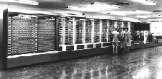
- Who invented the term “debugging”?
- What was the problem with using valves in computers?
- Where were the first integrated circuits used?
- How old was Bill Gates when he first got interested in programming?
- Who did Bill Gates talk into letting him create their operating system?
- When was the Apple 1 computer first sold?
- When was the iPod first sold?
- Who started the company Google?
- When was Wikipedia founded?
- When did YouTube first appear online?

