Annotation

It is essential that you annotate all of your work to explain the reasons why you chose to do something. This helps your teacher to see that you really do understand what you have been.

Annotation can be done by using call-out boxes (from the drawing toolbar) or text boxes and arrows or you could print out your work and annotate it by hand. Any method is suitable.

Below is an example of some poor annotation. This tells the teacher what you did but doesn’t tell them the reasons behind your choices.
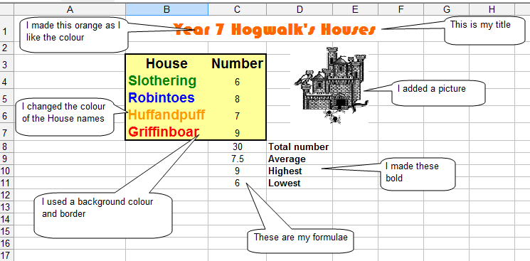
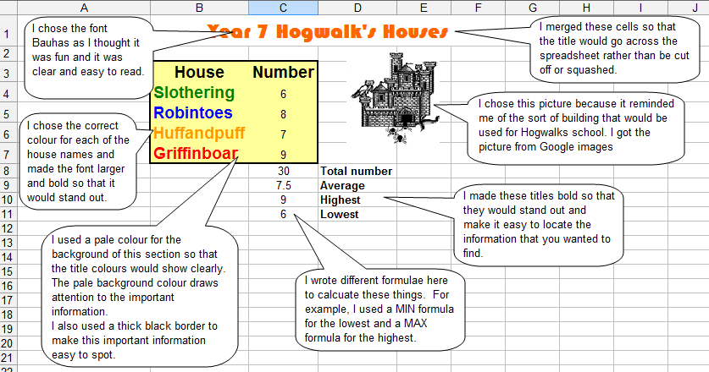
Now have a look at this second piece of annotation. Can you spot the difference?
If you want to get the highest possible marks for your project, this is how you should be annotating your work

