# Ideas for a solution:

OCR ICT unit 6

Writing the specification

**Success criteria:**

In this section of your specification you need to create an obvious success criteria that at the end of your project you can refer back to. I suggest that you make a table that you can copy into your review and tick off each item.

Example:

|  |  |
| --- | --- |
| **Task** | **completed** |
| **Make a logo** |  |
| **Can be resized** |  |

You could also do a bullet point list. Copy this into your review of the project and show which tasks you did actually complete (*tip you should have done them all to be successful*)

In addition you should also explain that to be successful you will need not just to create a good finished graphic, but also to show that you have used several tools to edit the different parts of your graphic. You want your graphic to stand out and show off the pet shop in a good way – so you will need to choose photographs and other images that make it look as good as possible.

### Software choices:

In this section you should make a comparison of the different software applications that you could use to make the logo.

Again you create a table for this with the software name and a list of advantages & disadvantages

|  |  |  |
| --- | --- | --- |
| Software | Advantages | Disadvantages |
| MS Word |  |  |
| Serif draw plus |  |  |

Or you could just use bullet points.

You need to write a conclusion for your final choice of software based on your comparison and how the software will help you to meet Sam’s requirements. It would be ok to say that you might use more than one application if you wanted to use different features from each e.g. wordart from MS Word and 3D filter from Serif.

### Ideas for a solution cont:

Explain how you might create the new logo. Maybe you might use 3 or 4 photos that you have taken or you might combine photos with drawings that you scanned into the computer and then could crop and cut out bits you liked.

Perhaps you could insert the pictures into your document and say why you liked them and which bits you might use.

Finally explain that your best logo choice should be shown separately in the website mock-up with comments to reason for file choice and how this fits Sam’s needs e.g. good quality, can be resized without loss of quality and will load quickly on the website as file size is not to large.

### The process:

In this section you should write about the actual steps you will take (the process).

You will start your design process by drawing some of your ideas on paper. These are your draft designs and will help you make choices as to which design looks best and meets your client requirements. You will ask each other for feedback and use this feedback to choose the best design or make improvements

|  |  |
| --- | --- |
| Steps |  |
| 1 | Draw at least 5 basic ideas in pencil |
| 2 | Get feedback and choose 2 or 3 designs |
| 3 | Re-draw your designs using colour |
| 4 | Get more feedback & choose final design |
| 5 | Create design in your chosen software – you will need to show all the steps and the software tools you use in the development of the logo |

Or you could just use bullet points.

You need to write a conclusion for your final choice of software based on your comparison and how the software will help you to meet Sam’s requirements. It would be ok to say that you might use more than one application if you wanted to use different features from each e.g. wordart from MS Word and 3D filter from Serif.

# Design plans:

Research methods

**Research:**

Explain the different types of research you can do e.g

Speak to pet shop owners

Watch TV adverts

Listen to radio adverts

Use the internet

Collect information and images from leaflets and magazines.

Explain how all this research will help to have more knowledge about this type of business and that you will get lots of good ideas for creating your logo.

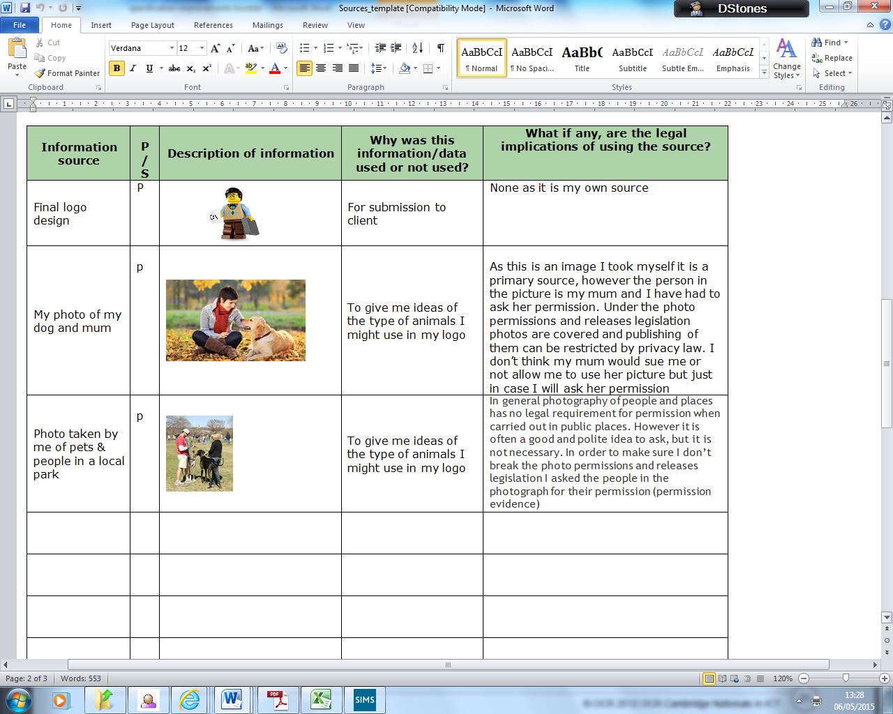

## Sources

You need to show you understand the legal implications for:

* copyright,
* Intellectual Property Rights;
* photo permissions and releases;

First you must research each area and explain when was the legislation introduced, who the legislation protects and what happens if the legislation is breached.

Next add some sources (at least 4) to your table to show you have considered these issues.

Eg you could have taken a picture of your pet in the park and put this in your sources table. However in the picture you can see some people. To avoid breaking photo permissions & releases you could ask the people for their permission to use their image.

Useful sites:

<http://tonysleep.co.uk/info/permissions-and-releases>

<http://www.digitalcameraworld.com/2013/02/12/is-it-legal-to-take-pictures-of-buildings-photography-law-questions-answered-by-experts/>

<https://www.gov.uk/intellectual-property-an-overview/overview>

Finally make sure you have said that some sites you did not use as you didn’t find the information useful, up to date or appropriate.

# Example