Small Basic

Task 1 – What School Year are you in?

Can you create IF statements for the other years in the school?

Task 2 – using the Object “clock”
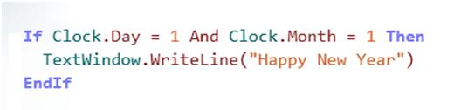

Task 3 – Breakfast or lunch?
