In this coursework, you have to create a 10 question powerpoint quiz for a company called Wind & Waves.
You will need to create a set of master-slides on powerpoint that will help you to advertise the business.
You will need:
- A title slide
- An instructions slide
- 10 question slides
- 10 correct slides
- 10 incorrect (wrong/try again) slides
- Final Slide
You will be expected to create templates using slide-master for each of the above 6 components.
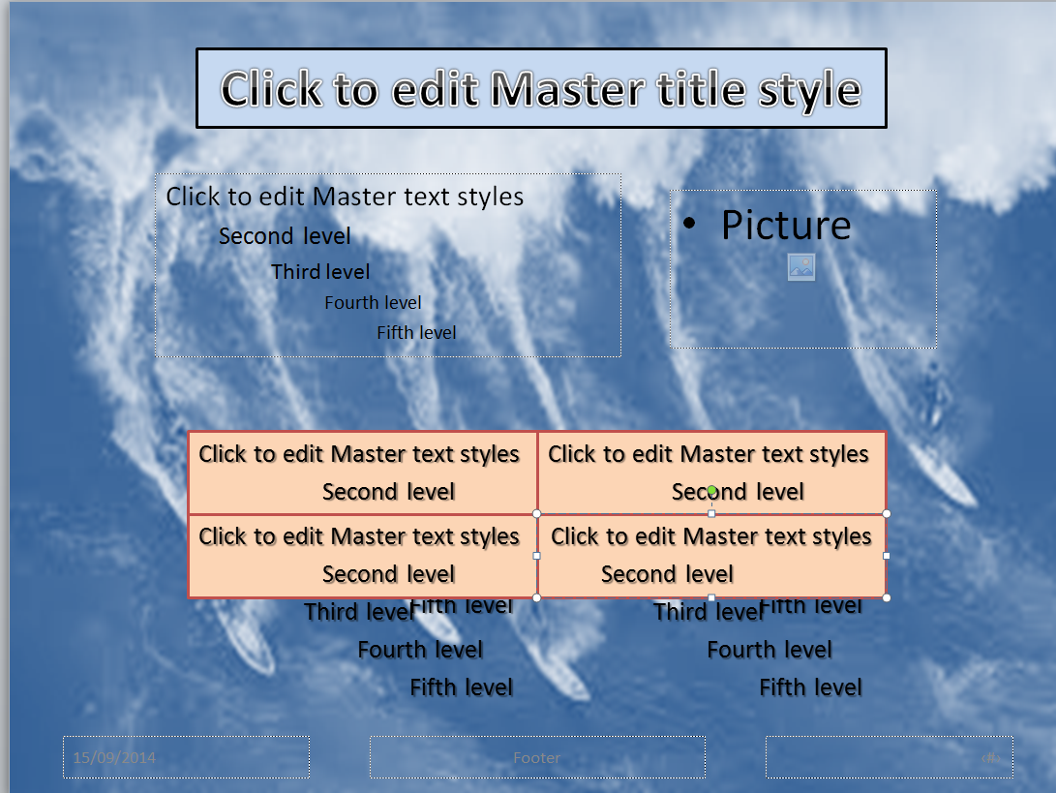
e.g
We create master slides to enable us to have a housestyle throughout our quiz and to save us time when we are creating it.
Plan
You must write an analysis of the task you have been given – Who/What/Why/Where/When/How..
You must draw out (on paper) a plan of how you would like each of your slides to look and highlight where any test boxes, pictures etc are.
You must create a navigation plan (flow chart) of how your slides (quiz) will work.
Source Table
As we work through this unit, you will be expected to keep an accurate and complete list of all the sources you use, eg websites (not google images – give the actual name of the website!!), leaflets, newspapers etc. You will remember you had a source table for the GCSE work you did in Year 9. You can delete all of the items from it and use the template if you like.
Testing
You must also test everything as you go along and keep a note of these tests, including printscreens where necessary. Please research the internet for examples of test tables.

Remember that your questions must help advertise the business in some way, not just be random questions!!!

