Name:
Copley Academy
Computing Department: Homework

- The following code has two errors. Rewrite the lines where the errors occur under the screenshot.
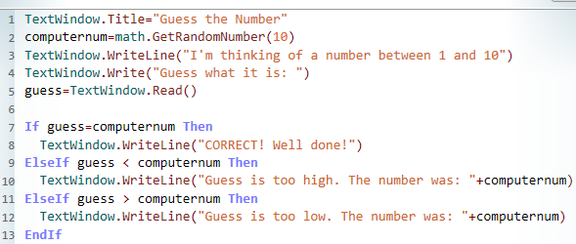

HA
Name:
Copley Academy
Computing Department: Homework Booklet
- The following code has two errors. Hi-light where the errors occur.

Name:
Copley Academy
Computing Department: Homework Booklet
- The following code has two errors. Hi-light where the errors occur.

LA

