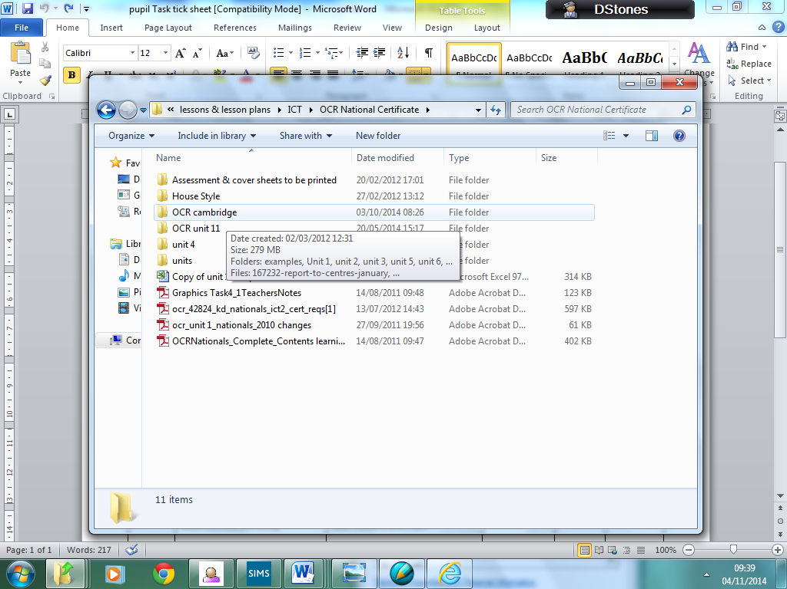

Take screen shots of your main OCR folder then take further screen shots of:

Your unit 1 2 5 & 6 folders

Open the unit 6 folder and screen shot your task1, 2 & 3 sub-folders

Finally take screen shots of the work you have saved in tasks 1 & 2

Make sure you have save your files in the correct folders

