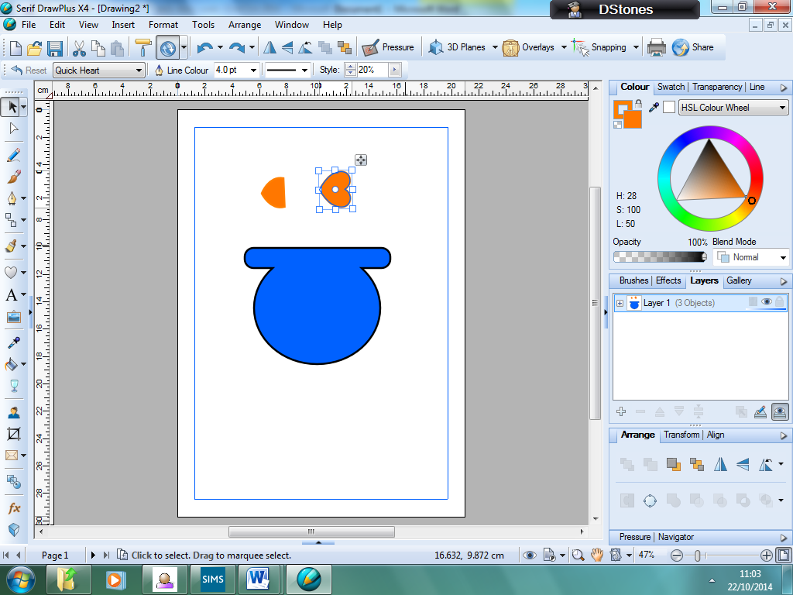

Show how you created the design and the tools you have used. Show each stage of the development. Explain what you are doing and try to match it to your client requirements.

e.g. I am creating an original image for the client so that there will not be any copyright issues.

